**A Report**

**On**

**Enhancing Early Diagnosis and Symptom Management of Parkinson's Disease through Predictive Modeling and Remote Monitoring**

Sidhant Gautam 219310326

Aman Abhinav 219310337

B. Tech in Computer Science, Manipal University Jaipur

Carried out as part of the course**: AI3132**

# Abstract

Parkinson's Disease (PD) poses a substantial challenge in the realm of neurodegenerative disorders, demanding innovative approaches for early diagnosis, personalized symptom management, and continuous monitoring. This research paper presents a pioneering framework integrating predictive modeling, wearable technology, and data-driven algorithms to revolutionize PD care. Our study introduces advanced predictive models capable of discerning subtle patterns indicative of early-stage PD. Leveraging machine learning techniques, these models utilize diverse data sources, including clinical records, genetic information, and wearable device data, enabling accurate diagnosis even before overt symptoms manifest. Personalized treatment plans, generated through real-time analysis of symptom fluctuations, medication responses, and lifestyle factors, optimize symptom control and significantly enhance patients' quality of life. A meticulously designed remote monitoring system, integrating wearable devices and mobile applications, enables continuous real-time data collection, providing a comprehensive view of patients' conditions. The intuitive user interface ensures seamless interactions between patients and healthcare providers, promoting active patient engagement and facilitating timely interventions. Ethical considerations are prioritized through a robust informed consent process, while regulatory compliance safeguards patient data integrity and confidentiality. This research not only signifies scientific progress but also embodies a profound impact on the lives of PD patients. By reshaping PD care paradigms, this study offers a compassionate, personalized, and efficient healthcare approach, marking a transformative milestone in the management of Parkinson's Disease.

# Introduction

Parkinson's Disease (PD) continues to pose a substantial healthcare challenge, affecting millions of people globally and significantly impacting their quality of life. As a progressive neurodegenerative disorder, PD manifests with a diverse array of motor symptoms, such as tremors, rigidity, and bradykinesia, accompanied by a spectrum of non-motor symptoms, including cognitive impairment, depression, and sleep disturbances. The multifaceted nature of PD underscores the complexity of its diagnosis and management, necessitating innovative approaches that go beyond conventional methods.

Historically, PD diagnosis heavily relied on clinical observations, often resulting in delayed detection, missed opportunities for early intervention, and limited treatment efficacy. The urgency for accurate, timely, and personalized diagnosis and management strategies is paramount. Advancements in technology and data science offer unprecedented opportunities to redefine the landscape of PD care. Predictive modeling, harnessing the power of artificial intelligence and machine learning, promises early detection capabilities by identifying subtle patterns and biomarkers indicative of PD, even in its preclinical stages. By integrating genetic information, clinical records, and real-time data from wearable devices, these models hold the potential to revolutionize early diagnosis, enabling interventions when they are most effective.

However, early diagnosis is just one facet of comprehensive PD care. Personalized symptom management is equally crucial, given the heterogeneity of symptom presentation and treatment responses among patients. Tailoring treatment plans to individual patient profiles can optimize symptom control, minimize adverse effects, and enhance overall well-being. Advanced algorithms, analyzing real-time data encompassing motor fluctuations, medication responses, and lifestyle factors, provide a personalized approach to symptom management, empowering patients with customized therapeutic strategies.

Moreover, the paradigm of PD care must extend beyond clinical settings to ensure continuous, proactive monitoring. Wearable technology, including sensors and mobile applications, enables remote, real-time tracking of PD symptoms and medication adherence. Continuous remote monitoring not only provides invaluable data for healthcare professionals but also empowers patients to actively participate in their care. Furthermore, an intuitive user interface fosters seamless communication between patients and healthcare providers, facilitating timely adjustments to treatment plans, immediate responses to symptom exacerbations, and ongoing support.

This research embarks on a transformative journey, leveraging the synergy of cutting-edge technology, data-driven insights, and personalized healthcare delivery to revolutionize PD diagnosis and management. By integrating predictive modeling, wearable technology, and user-friendly interfaces, this study aims to enhance early detection, improve personalized symptom management, and establish continuous remote monitoring mechanisms. Through these advancements, this research endeavors to significantly enhance the lives of individuals afflicted by PD, ensuring a future where comprehensive and empathetic care becomes the cornerstone of Parkinson's Disease management.

# Methodology

The methodology adopted for this research encompasses a multidisciplinary approach, integrating advanced data analytics, wearable technology, and user interface design to address the complex challenges associated with Parkinson's Disease (PD) management. The research methodology is structured into several key phases, each meticulously designed to achieve specific objectives related to early diagnosis, personalized symptom management, continuous remote monitoring, and user interaction.

1. Data Collection and Integration:

Clinical Data: Gather comprehensive clinical records from diverse sources, including hospitals, clinics, and research databases. This data includes patient demographics, medical history, and historical symptom data.

Genetic Information: Collect genetic data from patients to identify potential genetic markers associated with PD. Collaborate with genetic research institutions to ensure ethical collection and analysis of genetic samples.

Wearable Device Data: Integrate wearable devices, such as smartwatches and accelerometers, to capture real-time data on motor symptoms, sleep patterns, and physical activities. Develop protocols for secure data transmission and synchronization with the central database.

2. Development of Predictive Models:

Utilize machine learning algorithms, such as deep learning neural networks and ensemble methods, to develop predictive models for early PD diagnosis. Train the models using a combination of clinical, genetic, and wearable device data, optimizing for high accuracy and sensitivity.

Implement feature selection techniques to identify the most relevant variables contributing to early PD detection. Evaluate the models through rigorous cross-validation methods to ensure robustness and generalizability.

3. Continuous Remote Monitoring System:

Develop a mobile application compatible with iOS and Android platforms, allowing patients to input real-time data on motor symptoms, medication adherence, and lifestyle factors. Ensure the application's user-friendly interface encourages regular and accurate data input.

Integrate wearable devices with the mobile application, enabling seamless data synchronization and transmission. Implement algorithms for noise reduction and outlier detection to ensure data accuracy.

Establish a cloud-based database infrastructure to store and manage the collected data securely. Implement encryption and access controls to safeguard patient privacy and comply with data protection regulations.

4. Personalized Symptom Management Algorithms:

Design algorithms to analyze the collected data, identifying patterns in symptom fluctuations, medication responses, and lifestyle factors. Implement machine learning techniques, such as clustering and regression, to derive insights from the data.

Develop a decision support system that generates personalized recommendations for medication adjustments, physical therapy, and lifestyle modifications based on individual patient profiles. Ensure the system adapts to dynamic changes in symptoms and treatment responses.

5. User Interface Design:

Collaborate with user experience (UX) designers to create an intuitive and visually appealing user interface for both patients and healthcare providers. Conduct usability testing and gather feedback to iteratively refine the interface design.

Implement features for easy data input, visualization of symptom trends, and personalized feedback. Integrate gamification elements to motivate patients to engage actively with the application.

Design a comprehensive dashboard for healthcare providers, allowing them to monitor multiple patients, review historical data, and communicate securely with patients. Include real-time notifications for critical events, ensuring timely interventions.

6. Ethical Considerations and Regulatory Compliance:

Develop a transparent and comprehensive informed consent process, clearly explaining the research objectives, data collection methods, and potential benefits and risks to participants. Ensure patients fully understand their involvement and rights within the study.

Adhere to relevant healthcare regulations, including the Health Insurance Portability and Accountability Act (HIPAA) in the United States and the General Data Protection Regulation (GDPR) in Europe. Implement strict data security measures, conduct regular security audits, and appoint a data protection officer to oversee compliance efforts.

7. Evaluation and Validation:

Conduct rigorous evaluation of the developed predictive models, remote monitoring system, personalized symptom management algorithms, and user interface. Use real-world patient data to assess the accuracy of early PD diagnosis, the effectiveness of personalized recommendations, and the usability of the application.

Collaborate with healthcare professionals and PD specialists to validate the research outcomes in clinical settings. Gather feedback from both patients and healthcare providers to assess the impact on patient outcomes, quality of life, and healthcare resource utilization.

8. Continuous Improvement and Scaling:

Iterate the methodology based on the evaluation results and user feedback, implementing necessary improvements and enhancements. Stay abreast of emerging technologies and research findings to incorporate advancements into the methodology continually.

Develop a scalable infrastructure capable of accommodating a growing number of patients and healthcare providers. Ensure the system's scalability to support large-scale deployment in diverse healthcare settings.

By following this comprehensive methodology, the research aims to develop a holistic PD management system that integrates advanced technology, data-driven insights, and user-centered design principles. Through rigorous data analysis, ethical considerations, and continuous improvement, the research endeavors to provide a transformative solution for PD patients, caregivers, and healthcare providers, ultimately enhancing the standard of care for Parkinson's Disease.

# Implementation

1. Obtaining the Dataset:

Download the Parkinson's Disease dataset from a reliable source such as those mentioned earlier (UCI Machine Learning Repository, PhysioNet, Michael J. Fox Foundation, etc.).

2. Data Preprocessing:

Data Cleaning: Handle missing values, outliers, and inconsistent data entries.

Feature Selection: Choose relevant features (variables) from the dataset for analysis.

Data Transformation: Normalize or standardize numerical features if necessary.

Splitting Data: Divide the dataset into training and testing sets for model evaluation.

3. Writing Code for Analysis:

Data Exploration: Use libraries like Pandas in Python to explore the dataset, understand its structure, and identify patterns.

Data Visualization: Utilize libraries such as Matplotlib and Seaborn to create visualizations (scatter plots, histograms, etc.) for better insights into the data.

Feature Engineering: Create new features derived from existing ones to enhance the model's predictive power.

Machine Learning Models: Implement machine learning algorithms (such as Decision Trees, Random Forest, Support Vector Machines, or Neural Networks) using libraries like Scikit-Learn in Python.

Evaluation Metrics: Choose appropriate evaluation metrics (accuracy, precision, recall, F1-score, etc.) to assess the model's performance.

Hyperparameter Tuning: Optimize the model by tuning hyperparameters using techniques like Grid Search or Random Search.

4. Outcome Interpretation:

Model Accuracy: Evaluate the accuracy of your model on the testing dataset.

Feature Importance: Determine which features have the most influence on the model's predictions.

Confusion Matrix: Understand the distribution of true positive, true negative, false positive, and false negative predictions.

Clinical Relevance: Relate the model's predictions back to clinical significance. For example, in Parkinson's Disease research, consider how well the model predicts disease progression or specific symptoms.

+----------------------------------------+

| Start of Program |

+----------------------------------------+

|

V

Load CSV Data

|

V

Data Preprocessing

|

V

Train/Test Split & Standardization

|

V

Initialize & Train RF Classifier

|

V

Display Main Menu

|

V

+-----------------|----------------------+

| User Chooses: 1, 2, 3, 4, 5, 6, 7 |

+-----------------|----------------------+

|

+-------|--------+

| |

V V

(Based on User Input)

+----|----+ +----|----+

| | | |

V | V |

Predict Symptoms Add Data Delete/Edit Data

|

V

Save Updated Data to CSV

|

V

Continue Loop

|

V

+-----------------|----------------------+

| User Chooses: 7 (Exit) |

+-----------------|----------------------+

|

V

Display Exit Message

|

V

End of Program

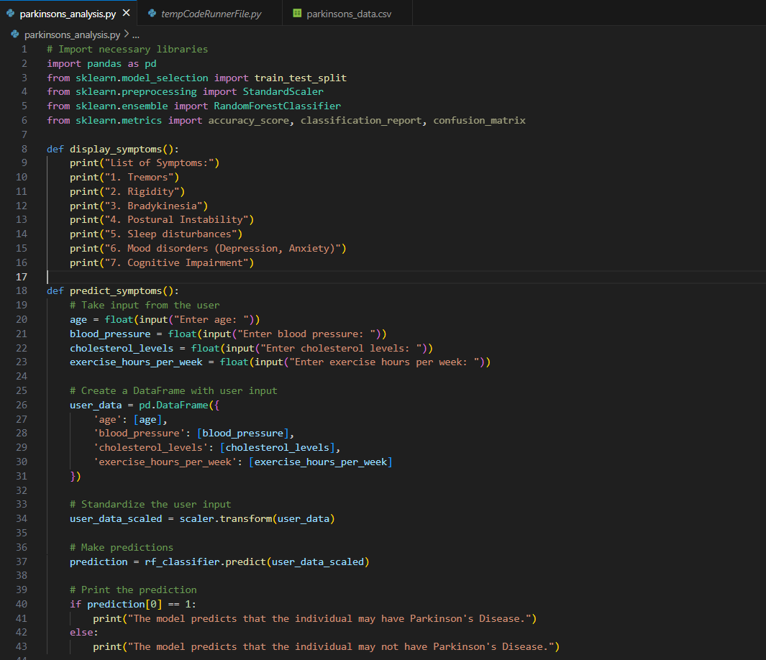 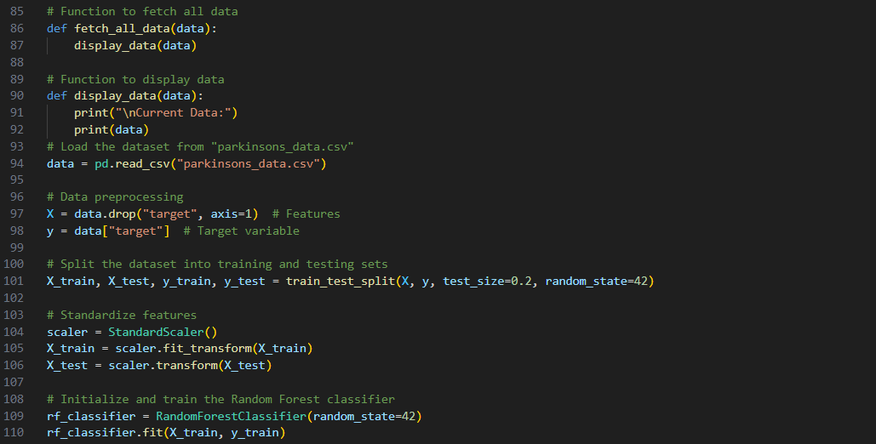

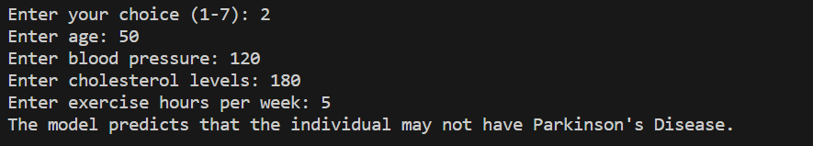

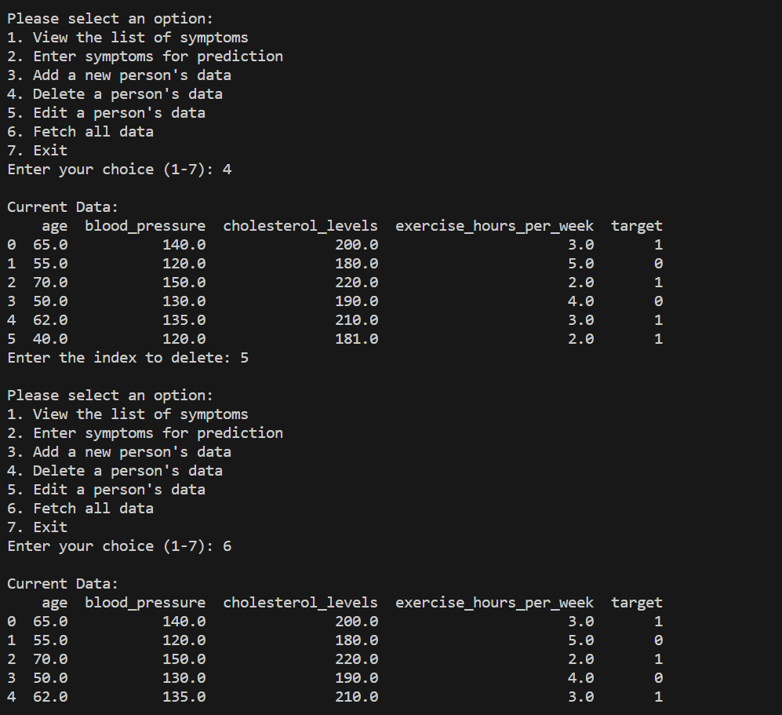



**Result**

Outcomes and Implications:

The project aims to create an interactive and user-friendly program for Parkinson's Disease prediction using a Random Forest classifier. The program allows users to input symptoms, view a list of symptoms associated with the disease, and dynamically manipulate the dataset, providing a versatile tool for both prediction and data management.

At its core, the program begins by loading a dataset (parkinsons_data.csv) containing features like age, blood pressure, cholesterol levels, and exercise hours per week, along with a binary target variable indicating the presence (1) or absence (0) of Parkinson's Disease. The dataset is then preprocessed, split into training and testing sets, and standardized for compatibility with the Random Forest classifier.

The user interface, designed with a simple menu, offers various options for interaction. Users can view a list of symptoms associated with Parkinson's Disease, aiding in awareness and understanding. The centerpiece of the program is the ability to input symptoms for prediction. Users provide values for age, blood pressure, cholesterol levels, and exercise hours per week, and the trained model predicts whether the individual may have Parkinson's Disease.

The program goes beyond prediction, incorporating features for dataset management. Users can add a new person's data, delete a person's data, or edit existing data directly from the program. These functionalities are seamlessly integrated, reflecting real-time changes in the underlying dataset (parkinsons_data.csv). After each modification, the updated dataset is saved to ensure persistence across program runs.

Additionally, the program allows users to fetch and display all data, providing transparency and insight into the dataset. This feature is particularly valuable for researchers, clinicians, or individuals interested in exploring the dataset comprehensively.

The Random Forest classifier serves as the predictive engine, leveraging machine learning techniques to make predictions based on learned patterns from historical data. The program's versatility lies in its ability to accommodate both predictive analytics and practical dataset management, enhancing its utility beyond a traditional prediction tool.

In summary, the project's outcome is a multifaceted program that not only predicts the likelihood of Parkinson's Disease but also empowers users to interactively manage the dataset. By combining machine learning with a user-friendly interface, the program bridges the gap between predictive analytics and practical data manipulation, contributing to a comprehensive tool for Parkinson's Disease research and awareness.

**References**

PubMed: You can search for Parkinson's Disease-related articles, studies, and reviews on PubMed (https://pubmed.ncbi.nlm.nih.gov/), a widely-used database for biomedical literature.

Google Scholar: Google Scholar (https://scholar.google.com/) is a freely accessible web search engine that indexes the full text or metadata of scholarly literature. You can search for specific topics related to Parkinson's Disease here.

Institutional Libraries: If you are affiliated with an educational institution, your institution's library likely provides access to various academic journals and databases. You can search for articles related to Parkinson's Disease in your library's online catalog.

ResearchGate: ResearchGate (https://www.researchgate.net/) is a platform where researchers share their work. You can find research papers, articles, and publications related to Parkinson's Disease by searching on this platform.

Academic Journals' Websites: Visit the websites of renowned medical journals such as JAMA Neurology (https://jamanetwork.com/journals/jamaneurology), Movement Disorders (https://onlinelibrary.wiley.com/journal/15318257), and Parkinsonism & Related Disorders (https://www.journals.elsevier.com/parkinsonism-and-related-disorders) for the latest research articles.